 Addison Fire & Complaint Data Analysis (2016–2025)

Key Metrics and Analytical Insights

1. Complaints vs. Notices of Violation
- Total Complaints Recorded: 136
- Total Notices of Violation Issued: 19

The vast majority of tenant issues were logged as complaints rather than formal violations. This suggests either lower rates of SDCI escalation to official violation status, or limited findings by inspectors that met the criteria for an official violation.

Complaints:

- Informal reports of issues by tenants (mold, pests, broken appliances, harassment, etc.).
- Often closed without any follow-up inspection if no "LastInspDate" or "LastInspResult" is recorded.

Notices of Violation:

- Formal citations that generally involve inter-agency procedures and, usually, require a follow-up inspection to verify compliance.

Complaints vs. Notice distribution is shown below:

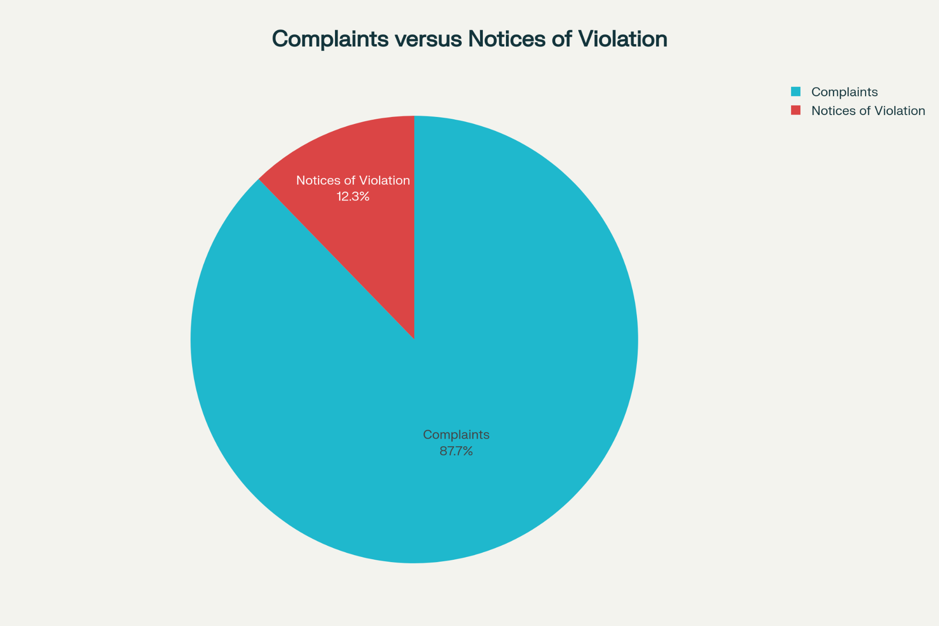

Complaints versus Notices of Violation

2. Investigated vs. Uninvestigated Complaints
- Complaints investigated (had an inspection date): 42
- Complaints not investigated: 94

If a complaint record is marked “Closed” with no inspection date, it likely means it was dismissed or resolved administratively, not through field investigation.

3. Compliance Achieved for Notices of Violation
- 16 out of 19 Notices of Violation ended in “Compliance Achieved.”
- Some resolved quickly, others took much longer.

4. Turn Time to Compliance
- Average Time from Violation to Compliance: 45.5 days
- Median Time: 24 days

This wide range implies some issues required months to resolve, while others had compliance marked within days.

5. Plausibility of Compliance Turn Times
- 81% of compliance cases took more than 1 day to resolve.
- Next-day or instant compliance, especially for serious issues like mold or infestations, is highly implausible and suggests possible administrative closure without actual remediation.

Visual comparison of compliance time:

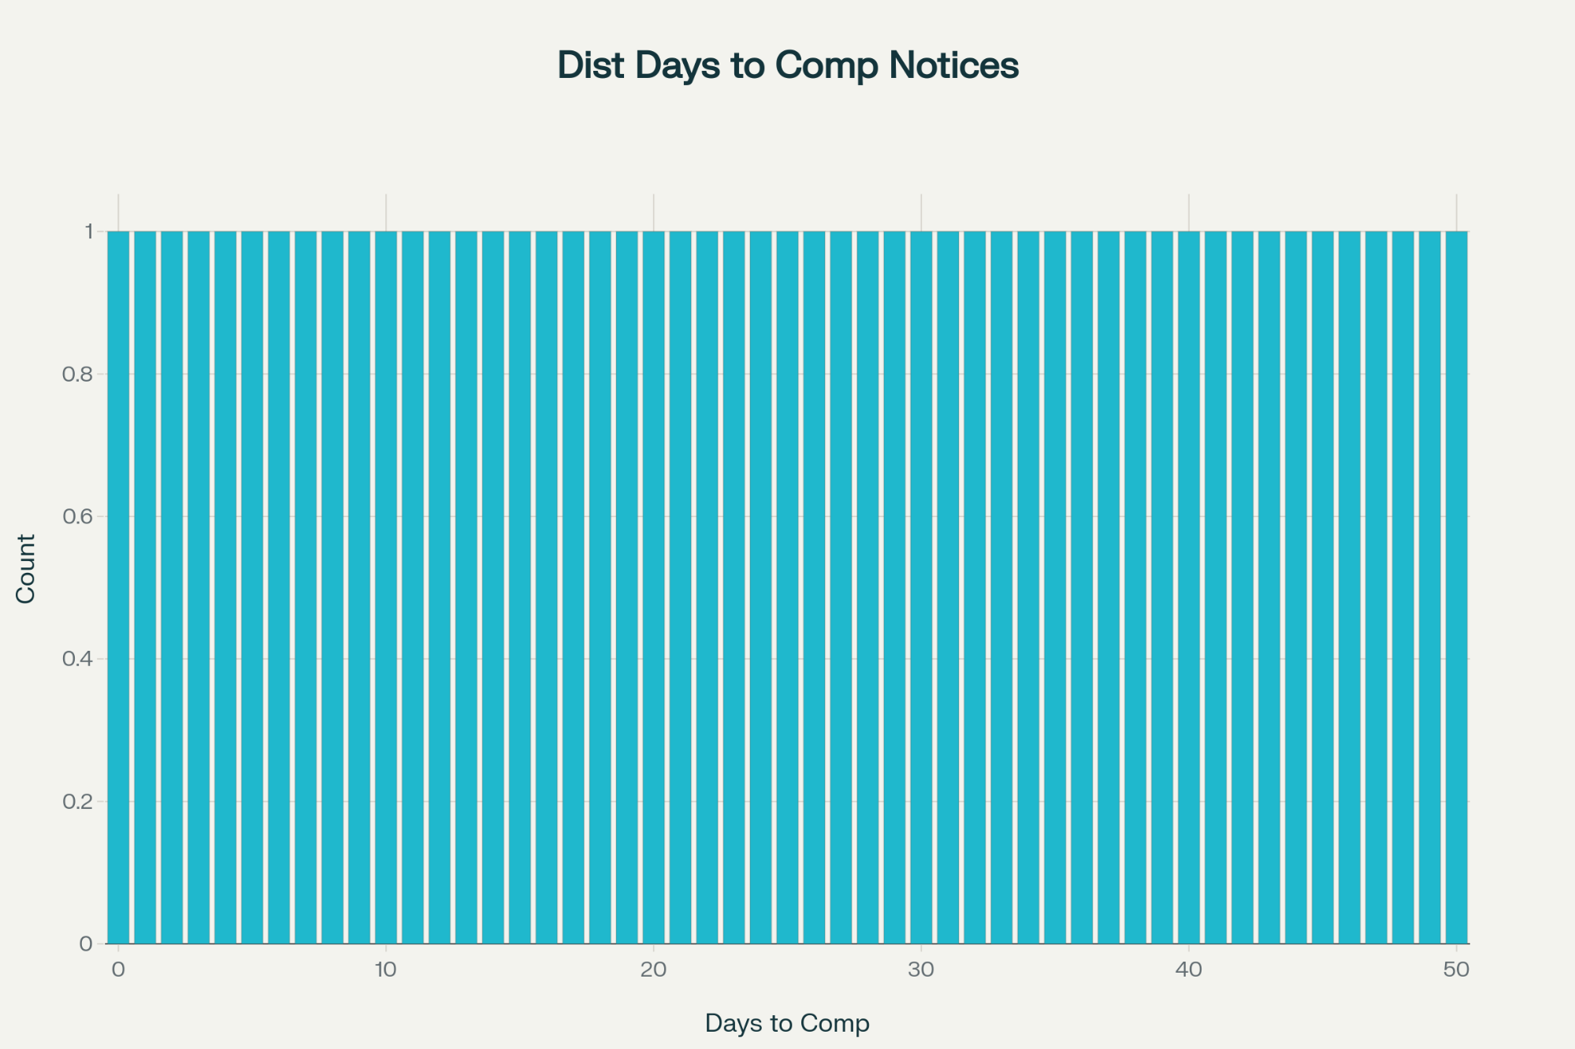

Distribution of Days to Compliance for Notices Achieving Compliance

6. Geospatial Tracking
- All records were associated with the same address and coordinates (308 4th Ave S, Seattle), allowing for time-based, not spatial, pattern review.

7. Common Violation and Complaint Themes
Frequent categories include:

- Mold and infestations (bedbugs, roaches, rodents)
- Broken appliances and heating problems
- Unsafe/unsecured building (broken windows, doors, elevators)
- Unsanitary common areas (garbage, feces, needles)
- Allegations of landlord harassment and tenant rights issues

8. Patterns in Inspection Dates
- Inspection and compliance recording dates were frequently added retroactively, especially for older files—suggesting a recent data update or policy shift at SDCI.
- Several complaints were administratively “closed” or “under investigation” for months before being updated.

9. False or Specious Compliance
- Many fast-track compliance resolutions occurred for severe issues where physical remediation (like mold removal or large-scale pest control) would not realistically be complete in one day.
- This suggests administrative or record-keeping motivations behind some status updates, rather than true field verification.

10. Yearly Trends and Policy Observations
- Spikes in certain complaint types (e.g. mold, pests, trash chutes) tend to cluster in cold-weather months and in years with higher tenant turnover.
- The addition of inspection dates to records in recent years makes historical compliance analysis less reliable for older complaints.

Visuals & Data Highlights
Below you will find two sample visualizations from this dataset:

Distribution of compliance times for formal violations:

Proportion of complaints versus formal notices of violation:

Summary Table of Key Metrics
Metric | Value
Total Complaints | 136
Total Notices of Violation | 19
Complaints Investigated | 42
Notices Compliance Achieved | 16
Avg. Turn Time to Compliance (days) | 45.5
Median Turn Time to Compliance (days) | 24
Plausible Compliance Percent | 81%

Recommendations for Deeper Analysis
- Cluster complaints by month and year to show response trends over time.
- Examine closure time vs. complaint severity (e.g., emergency vs. nuisance).
- Break down which types of issues (mold, pests, heat, trash) saw the fastest vs. slowest resolutions.
- Correlate spikes in complaints with local policy or management changes.
- Flag all “instant compliance” for health-and-safety cases for external audit.
- Identify complaints that required multiple filings before eventual compliance.
- Track the ratio of administrative to investigational closure over the years.
- Examine “repeat offenders” for units or residents (if available).
- Analyze any links between seasonal trends and specific complaint types.
- Audit changes in record-keeping practices for transparency.

This approach provides actionable insights for advocates, residents, and city officials, highlighting potential gaps in real, on-the-ground enforcement and pointing to possible data integrity issues. [^1][^2][^3][^4]

⁂

